# CS 255 Business Requirements Document Template

Complete this template by replacing the bracketed text with the relevant information.

This template lays out all the different sections that you need to complete for Project One. Each section has guiding questions to prompt your thinking. These questions are meant to guide your initial responses to each area. You are encouraged to go beyond these questions using what you have learned in your readings. You will need to continually reference the interview transcript as you work to make sure that you are addressing your client’s needs. There is no required length for the final document. Instead, the goal is to complete each section based on your client’s needs.

**Tip:** You should respond in a bulleted list for each section. This will make your thoughts easier to reference when you move into the design phase for Project Two. One starter bullet has been provided for you in each section, but you will need to add more.

## System Components and Design

### Purpose

*What is the purpose of this project? Who is the client and what do they want their system to be able to do?*

* The client is DriverPass
* They want the system to offer a booking service as well as online lessons and tests for whoever has an account registered with them
* There also should be the ability to make modifications from the IT end

### System Background

*What does DriverPass want the system to do? What is the problem they want to fix? What are the different components needed for this system?*

* The problem at hand is too many people failing drivers tests, and DriverPass wants to make a system that helps driving students

### Objectives and Goals

*What should this system be able to do when it is completed? What measurable tasks need to be included in the system design to achieve this?*

* The system should provide several different capabilities, including:
  + Logging in/out
  + Booking appointments
  + Choosing packages
  + Online tests
  + Connection to DMV
* The system should be connected to the cloud
* For Liam, Ian, and the secretary, they should be able to modify the system, track any changes made, and Liam should have access to every account in the system as an administrator
* The secretary should be able to book appointments for other people if they call to schedule
* For regular users, the system should be able to book appointments for driving lessons, provide access to online lessons, let them log in/out, and change their password if needed

## Requirements

### Nonfunctional Requirements

*In this section, you will detail the different nonfunctional requirements for the DriverPass system. You will need to think about the different things that the system needs to function properly.*

#### Performance Requirements

*What environments (web-based, application, etc.) does this system need to run in? How fast should the system run? How often should the system be updated?*

* This system should be able to run online and offline to access data
* Since it needs to have offline access, it will need an application environment, both mobile and desktop
* The system will run over the cloud
* The system shall be connected to the DMV’s website
* It will be updated monthly

#### Platform Constraints

*What platforms (Windows, Unix, etc.) should the system run on? Does the back end require any tools, such as a database, to support this application?*

* All common mobile and desktop platforms should be able to run this system
* Windows, MacOS, iOS, and Android

#### Accuracy and Precision

*How will you distinguish between different users?* *Is the input case-sensitive? When should the system inform the admin of a problem?*

* Each user will have a different username – it is not case sensitive
* The system will inform an admin when it detects a mass hacking or DDOS attempt. Individual hacking attempts will not be alerted to anyone except the user who owns the account
* There should be a distinction between regular users and admins

#### Adaptability

*Can you make changes to the user (add/remove/modify) without changing code? How will the system adapt to platform updates? What type of access does the IT admin need?*

* The admin can modify user accounts and block access for terminated employees
* Admin also needs access to reports and be able to download them offline
* Developers must modify features such as modules
* The IT admin will be able to
  + Maintain the system
  + Modify the system
* The IT admin can work with developers to modify features requested by Liam in the future

#### Security

*What is required for the user to log in? How can you secure the connection or the data exchange between the client and the server? What should happen to the account if there is a “brute force” hacking attempt? What happens if the user forgets their password?*

* Username and password is required for each user
* Connection is secured using encryption
* If an account has any record of password changes or if suspicious activity is detected (for example, scheduling and paying for many appointments at once), the original email on the account will receive a message from the system alerting them of the activity
  + The user will get the opportunity to change their password immediately
* Overall security will be handled externally, not by the organization, since it will run on the cloud

### Functional Requirements

*Using the information from the scenario, think about the different functions the system needs to provide. Each of your bullets should start with “The system shall . . .” For example, one functional requirement might be, “The system shall validate user credentials when logging in.”*

* The system shall authenticate each new and existing user when logging in
* The system shall prevent users from accessing the administrative section of the system
* The system shall have a checkout system for users purchasing packages
* The system shall have an online learning and testing system

### User Interface

*What are the needs of the interface? Who are the different users for this interface? What will each user need to be able to do through the interface? How will the user interact with the interface (mobile, browser, etc.)?*

* The administrator has access to most of the system, and can modify the interface in certain ways
  + The admin cannot modify or remove modules – this must be done by a developer
* Users see what is on this sketch. They are allowed to:
  + Make accounts
  + Upload photos
  + Purchase packages
  + Upload information
  + Take online tests
  + View history of tests and statuses
  + View driver notes (NOT modify)

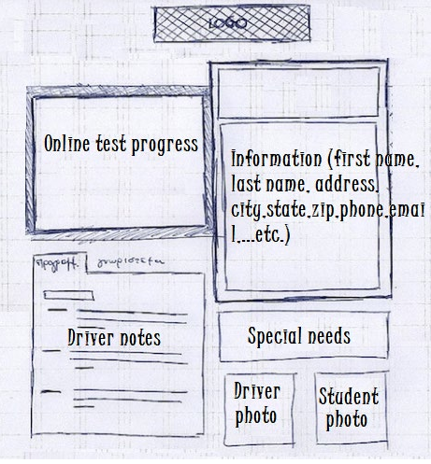

* The information section must include
  + First/last name
  + Address
  + Contact info
  + State
  + Credit card number
  + Security code
  + Pickup/drop-off location

### Assumptions

*What things were not specifically addressed in your design above? What assumptions are you making in your design about the users or the technology they have?*

* Users will want mobile access to the system
* The system must support multiple versions of each platform/OS, because users might not have the latest update
* Users will need a quick tutorial of how to do the tests, as they might not be experienced with online learning

### Limitations

*Any system you build will naturally have limitations. What limitations do you see in your system design? What limitations do you have as far as resources, time, budget, or technology?*

* The technology to make the system work on every device
* The resources to make modules modifiable/removeable without code
* The time constraints of each phase of the project

### Gantt Chart

*Please include a screenshot of the GANTT chart that you created with Lucidchart. Be sure to check that it meets the plan described by the characters in the interview.*

